**Correction**

1 - Write the code to create (=instanciate) an object Employee "ronan" , from "paris", with 0 year in the company

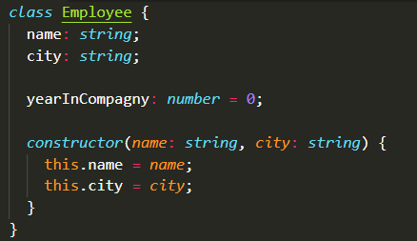

Answer:

let obj=new Employee('ronan','Paris')

2- Write the code to create (=instanciate) an object Employee "sovanda" , from "chacago ", with 3 yeasr in the compagny



Answer:

let obj = new Employee('Sovanda', 'Chicago')

obj.yearInCompany=3

3- What will this code produce ?

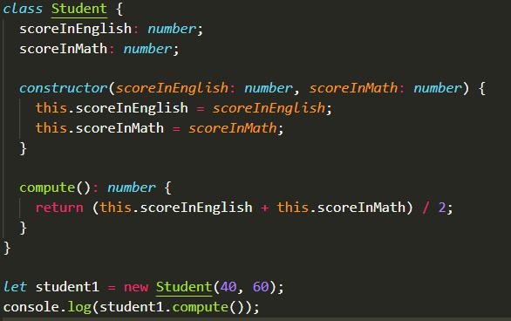

Answer:

50

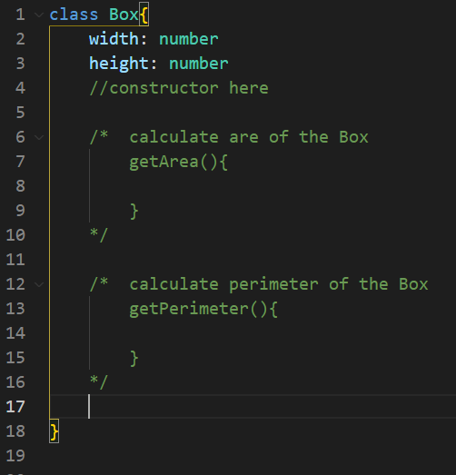4. Create constructor(width,height) of the class Box and implement function getArea and getPerimeter

* Create constructor

constructor(width: number, height: number) {

        this.width = width

        this.height=height

    }

* getArea function

getArea(): number{

        return this.width * this.height

    }

* getPerimeter function

 getPerimeter(): number{

        return(this.width+this.height)*2

    }

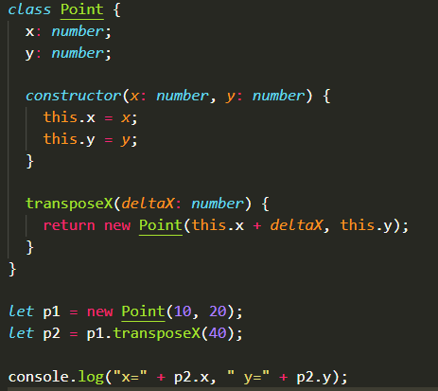5- What will be printed on console after this code execution ?

Answer:

x=50, y=20